**Lab no 10**

**File Manipulation**

***Objectives:***

* Implementation of file manipulation

**File Manipulation:**

Python has a wide array of file operations. These operations include opening a file, reading or writing to a file. There can be instances wherein you want to work with files directly, in which case you would use the file operations available in C#. Some of the basic file operations are mentioned below.

1. Reading – This operation is the basic read operation wherein data is read from a file.
2. Writing – This operation is the basic write operation wherein data is written to a file. By default, all existing contents are removed from the file, and new content is written.
3. Appending – This operation also involves writing information to a file. The only difference is that the existing data in a file is not overwritten. The new data to be written is added at the end of the file.

**StreamWriter Class**

The StreamWriter class implements TextWriter for writing character to stream in a particular format. The class contains the following method which are mostly used.

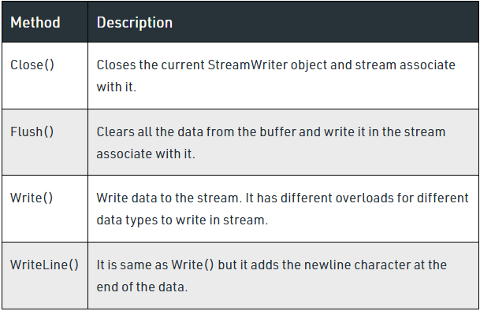

**StreamReader Class**

The StreamReader class implements TextReader for reading character from the stream in a particular format. The class contains the following method which is mostly used.

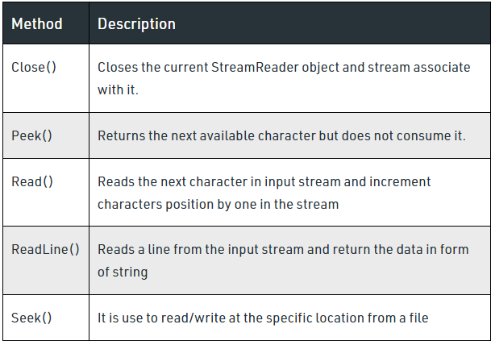

Class StreamReaderWriter:

Def __init__(self, stream, class_sr, class_sw):

Self.r = class_sr(stream)

Self.w = class_sw(stream)

Def read(self):

Return self.r.read()

Def write(self, data):

Return self.w.write(data)

#### TextReader Class and TextWriter Class

The TextReader Class has a reader that reads the characters from the file while the TextWriter Class has a writer that writes the characters into the file.

# Program to show various ways to read and

# write data in a file.

File1 = open(“myfile.txt”,”w”)

L = [“This is Australia \n”,”This is Paris \n”,”This is London \n”]

# \n is placed to indicate EOL (End of Line)

File1.write(“Hello \n”)

File1.writelines(L)

File1.close() #to change file access modes

File1 = open(“myfile.txt”,”r+”)

Print(“Output of Read function is “)

Print(file1.read())

Print()

# seek(n) takes the file handle to the nth

# bite from the beginning.

File1.seek(0)

Print( “Output of Readline function is “)

Print(file1.readline())

Print()

File1.seek(0)

# To show difference between read and readline

Print(“Output of Read(9) function is “)

Print(file1.read(9))

Print()

File1.seek(0)

Print(“Output of Readline(9) function is “)

Print(file1.readline(9))

File1.seek(0)

# readlines function

Print(“Output of Readlines function is “)

Print(file1.readlines())

Print()

File1.close()

#### BinaryReader Class and BinaryWriter Class

#### The BinaryReader Class reads the data types in the form of binary information and the BinaryWriter Class writes the binary information into the stream.

# Open a binary file

F = open(‘D:\PythonLogo.png’, ‘rb’)

# Read lines

Data = f.read()

# Display the data

Print(data)

# Open a file in binary format for writing

F = open(“E:\MyDemoBinary.bin”,”wb”)

# Elements to be added to the binary file

A = [100, 200, 300]

# Convert the integer elements to a bytearray

myArr = bytearray(a)

# The byte representation ius now written to the file

f.write(myArr)

f.close()

#### StringReader Class and StringWriter Class

The StringReader Class reads the data from the string using TextReader. Similarly, the StringWriter Class writes the data to the string using the TextWriter.

Def GetLinesFromText(text):

Reader = StringReader(text)

Lines = []

Try:

Line = reader.ReadLine()

While line is not None:

Lines.append(line)

Line = reader.ReadLine()

Finally:

Reader.Dispose()

Return lines

#open text file

Text_file = open(“D:/data.txt”, “w”)

#write string to file

N = text_file.write(‘Python Tutorial by TutorialKart.’)

#close file

Text_file.close()

Print(n)

**Task:**

* Build code for write and read data from file using string Reader and String Writer class.

Code:

# Program to show various ways to read and

# write data in a file.

file1 = open("myfile.txt","w")

L = ["This is Delhi \n","This is Paris \n","This is London \n"]

# \n is placed to indicate EOL (End of Line)

file1.write("Hello \n")

file1.writelines(L)

file1.close() #to change file access modes

file1 = open("myfile.txt","r+")

print("Output of Read function is ")

print(file1.read())

print()

# seek(n) takes the file handle to the nth

# bite from the beginning.

file1.seek(0)

print( "Output of Readline function is ")

print(file1.readline())

print()

file1.seek(0)

# To show difference between read and readline

print("Output of Read(9) function is ")

print(file1.read(9))

print()

file1.seek(0)

print("Output of Readline(9) function is ")

print(file1.readline(9))

file1.seek(0)

# readlines function

print("Output of Readlines function is ")

print(file1.readlines())

print()

file1.close()

Output:

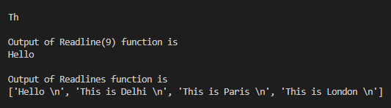

* Build code for write and read data from file using Binary Reader and Binary Writer class.

Code and ouput:

>>> f = open('C:\myfile.txt','w')

>>> f.write("Hello") # writing to file

5

>>> f.close()

# reading file

>>> f = open('C:\myfile.txt','r')

>>> f.read()

'Hello'

>>> f.close()